*Building Data Flow Diagrams*

*Ethan Dunzer*

*04/25/2021*

**Introduction**

A Data Flow Diagram is a system that is graphically represented. It can contain data flows, processes, sources, destinations, and stores. A Use Case Diagram shows you some of the use cases in your system, some of the actors in your system, and the relationships between them. Since data flows show what the users will be putting into the system and taking out it’s a much more detailed representation of the system.

By creating both the data flow level 0 and level 1 diagrams I am able to convey major tasks that are expected of employees through the new system, and also how they will connect to the different processes. The level 0 data flow diagram shows the employees right way what their main tasks will be and whether or not they are inputting information into the system or taking out information. Level 1 then will allow them to see where that data is going specific to there instance of work. Having this will allow APC’s team to learn their new system and its processes much faster and can clear up miscommunications that would arise if there were no visual representations.

**Topic Analysis**

**Part 1:****Create a Context Diagram for APC**

This diagram is a basic representation of the connections between APC’s new systems and their users. In the diagram we have all the types of employees and their possible tasks that they would input or output while using the system.

These connections where made and created in relation to the Use case Excel document that details what uses they would have for the system. Then from simple knowledge of the subject I determined if they were inputting data to the system or getting outputted data from it and created the appropriately directions connections.

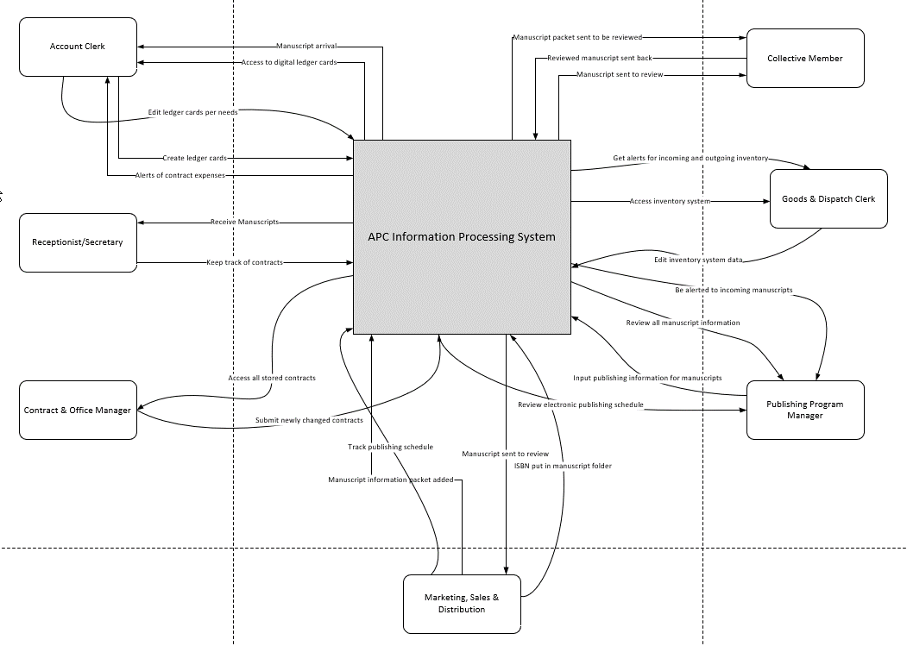

**Part 2:****Create a Level 1 diagram for APC**

As shown in the level 1 diagram ever connection is labeled with a number. This number is related to the major process that it is connected with. For instance, if a connection is with the Manuscript system process which is labeled number 3 any connection would then be 3.1 or 3.2 and as follows.

All data stores are only accessible through the processes in place because every one of those processes will be some sort of system. Whether that means a database that can be queried or just simply software that accesses another database with the information. This will allow triggered events to take place when actions occur and set standards for data to be inputted or taken out of the database.

All connections are mostly simple transactions between the system and a user as you can see from the descriptions. There are not many instances where daily users of the system would need to do something other then view, edit, or input new data.

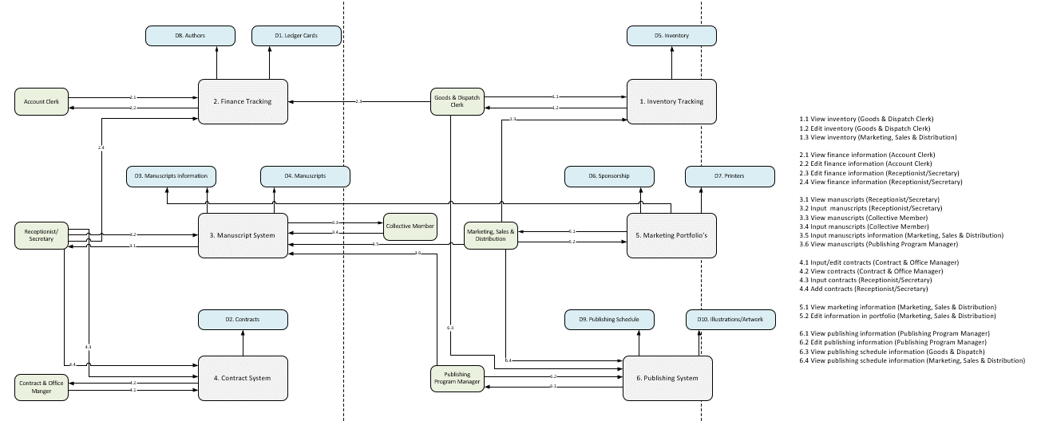

**Part 3***:* **Expand your most complex process from the level 1 diagram into a level 2 diagram.**

In this diagram there is a more in-depth explanation of what will happen in use case 3.2 as shown in level 1 of the data flow diagram. This explanation is achieved by going through the possible process of the (receptionist/secretary) at APC where a new manuscript arrives in the email that is designated for manuscripts. Then after creating a new manuscript folder in the manuscripts system an alert is then sent to relevant parties like (Marketing, Sales & Distribution) (Publishing Program Manager). This alert is put in place to allow publishing to create a new schedule and also just so major managing employees know what is happening. After the alert (receptionist/secretary) will take all information from the email and input into the folder that was created for the manuscript. Then the folder is given the appropriate naming convention, most likely author name first then manuscript title, and then the folder is passed into the manuscript system where it is accessible to other employees at any time.

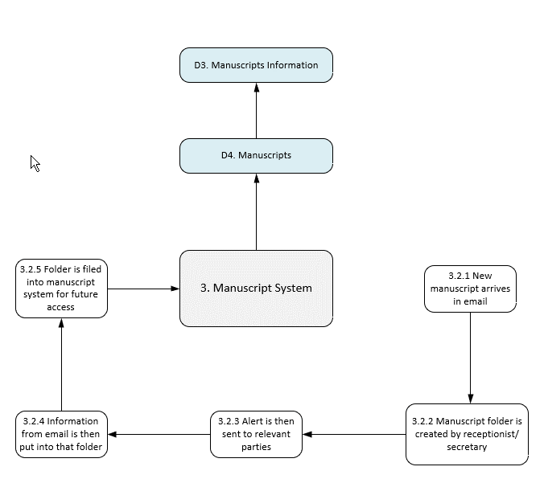

**Conclusion**

This seemed like a great way to demonstrate the ideas and processes that I outlined in previous assignments and how they can connect to each system through a visual medium. I really like how data flow diagrams plan out the flow of information for any process or system in a data exchange instance. And that the defined symbols like rectangles and arrows along with text labels could really show a viewer the routes between each process and destination.

I could easily see this tool as a great way to represent new system processes and functionality to a group that as little to no information about that new system. Being able to show the wide overview of all the processes and then bring it down through the levels really enables a great way to show and explain what is happening along with giving great information about the new system.